# Module 5 Comprehensive Guide

## Best Practices for Ensuring Model Generalizability

## 📌 Cross-Validation and Advanced Model Validation Techniques

Model validation is the process of assessing how well a machine learning model performs on **unseen data**. It is essential to ensure that the model is not overfitting the training data and is capable of **generalizing** to new inputs. In practice, model validation allows us to select and fine-tune models while preserving their predictive integrity on future, real-world data.

During model development, machine learning practitioners optimize the model by adjusting **hyperparameters**. However, if this tuning is done using the **test set**, it leads to a critical issue known as **data snooping**.

Instead of relying solely on the model’s performance during training, validation strategies assess how well the model performs on **data it hasn’t seen before**. This makes model validation essential for:

* Choosing between different model configurations.
* Tuning hyperparameters responsibly.
* Ensuring model robustness in real-world deployment.

### 🔹 Understanding Data Snooping and Data Leakage

Checking performance on the test data before you are done optimizing your model is called **data snooping**, a form of what's known as **data leakage**.

**Data snooping** refers to any situation where information from the **test data** leaks into the training or model selection process. This contamination often leads to **over-optimistic results** that don’t hold up in production.

Example: If you tune model hyperparameters based on the test set, you are essentially allowing the model to "peek" at future data. This gives a **false sense of performance**.

**Why is it dangerous?**

* Your model becomes tailored to a specific test set rather than a general solution.
* Performance estimates become unreliable.
* Deployment results are disappointing.

### 🔹 Proper Validation Workflow: Training, Validation, Testing

What can you do to validate your model to ensure it doesn't overfit itself to your test data? - we need to decouple model tuning from the final evaluation.

Validation means tuning your model on the training data, but only testing it on unseen test data once you are satisfied that it is well trained. There is no snooping involved.

To avoid data snooping and ensure fair evaluation, datasets **ideally should** be divided into **three distinct sets:**

**1. Training Set**

* Used to train the model and tune hyperparameters.
* The model learns patterns from this portion.

**2. Validation Set**

* Used to evaluate model performance during development.
* Helps in tuning hyperparameters or selecting between models.
* Never used for final evaluation.

**3. Test Set**

* Set aside until final model selection is complete.
* Used to assess generalization performance after training and tuning.
* Provides an unbiased estimate of model accuracy on unseen data.

**💡 This structure ensures each data subset has a specific purpose, preventing data leakage and improving model reliability.**

⚠️ If you split your data into **just a training and a test set**, and use the test set to select the best hyperparameters, you're essentially allowing your model to **"see" the test data during training**. This leads to **overfitting the test set**, **data snooping**

### 🔹 Cross-Validation (CV)

Cross-validation is a **critical model validation strategy** that helps ensure your model generalizes well to unseen data, especially during the **hyperparameter tuning** stage. It addresses several challenges that come with simpler validation techniques like train-test split — particularly the risks of **overfitting** and **data snooping**.

Cross-validation is an advanced model validation approach where the dataset is **split multiple times in a structured way** to evaluate model performance more thoroughly and prevent overfitting.

It involves:

* Dividing the training data into **training and validation subsets multiple times**.
* Training and evaluating the model on each combination.
* Aggregating the performance scores to get a more **reliable estimate** of how the model will behave on unseen data.

This way, the model **never "sees" the final test set** during training or tuning.

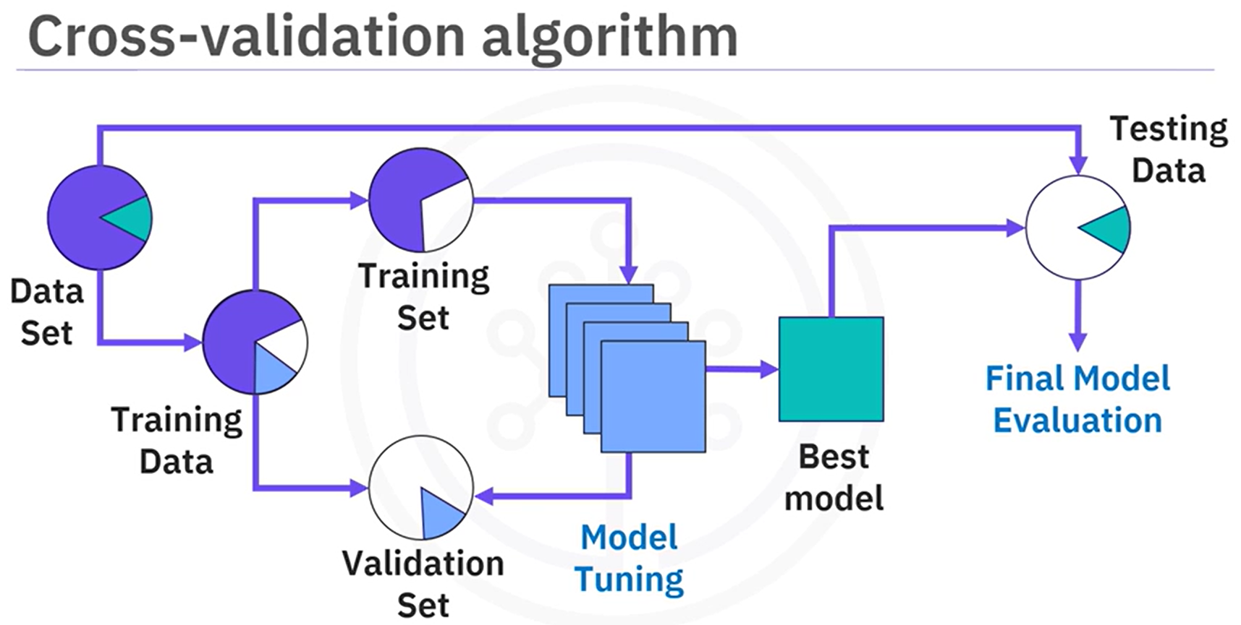

#### 🔹 K-Fold Cross-Validation (CV)

K-Fold CV is the most commonly used form of cross-validation.

**🔍 How it works:**

1. The dataset is **split into K equal parts** (called "folds").
2. For each of the K folds:
   * One-fold is held out as the **validation set**.
   * The remaining **K-1 folds** are used to **train the model**.
   * The model is evaluated on the validation fold.
3. This process is **repeated K times**, each time with a different fold as the validation set.
4. After all K iterations, the **average of the scores** (e.g., accuracy, F1, RMSE) is calculated to assess model performance.

✅ Benefits of K-Fold CV

* **Better data usage**: Every data point is used **for both training and validation**, which is especially useful when datasets are small.
* **Robust evaluation**: Since multiple validation sets are used, the performance metrics are **less sensitive to data partitioning**.
* **Prevents overfitting**: Helps in **smoothing out noise** or patterns that may exist only in a particular data split.
* **More reliable hyperparameter tuning**: Ensures that chosen model configurations generalize well.

📌 **K=5 or K=10** are common and effective choices.

#### 🔹 Stratified Cross-Validation (for Classification)

In classification problems with **imbalanced class distributions**, standard K-Fold may lead to folds where **some classes are underrepresented**. This skews evaluation results.

**🧩 Solution: Stratified K-Fold CV**

* Ensures that each fold **preserves the class distribution** of the full dataset.
* Prevents **evaluation bias**, especially for metrics like precision, recall, or F1 score.

The transcript highlights this as **critical for imbalanced datasets**, where naive splitting may give unreliable performance metrics.

#### 🔹 Regression and Skewed Target Variable

In **regression tasks**, instead of class imbalance, a common issue is **skewed distributions** in the target variable. Many models assume the target variable is **normally distributed**.

**🧩 Solutions:**

* **Logarithmic Transformation**: Applies a log function to compress large values.
* **Box-Cox Transformation**: More flexible; can normalize data using a power transformation.

These transformations:

* Reduce **skewness**.
* Make **residuals more symmetric**.
* Improve **linear model fit**.
* Stabilize **variance**.

💡 After transformation, models like **linear regression** become more effective at capturing relationships in the data.

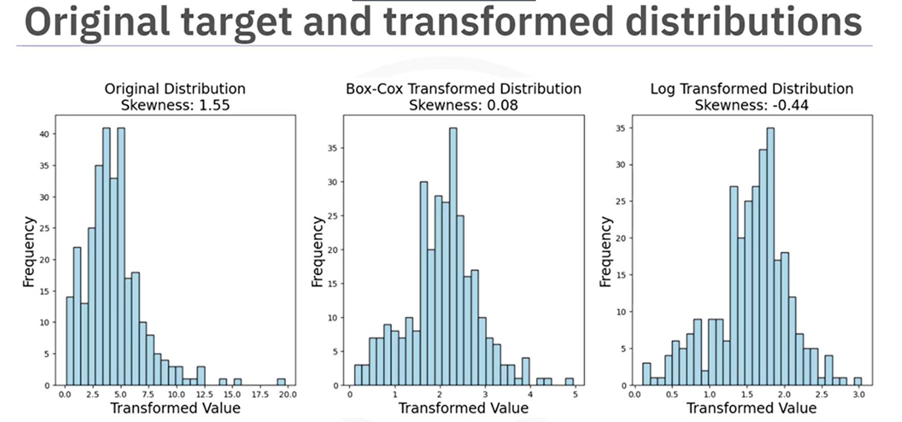

#### 🔹 Why Cross-Validation Improves Generalizability

* It exposes the model to **different subsets of the training data**, helping it **learn more generalizable patterns**.
* Models that consistently perform well across folds are more likely to **generalize to real-world, unseen data**.
* It reduces the risk of **selecting a model that only performs well on one particular split**.

## 📌 Regularization in Regression and Classification

Regularization is a **fundamental technique in regression modeling** aimed at **enhancing model generalizability** and **reducing overfitting**. In regression, overfitting occurs when a model learns not only the underlying patterns but also the noise in the training dataset, resulting in poor performance on unseen data. Regularization addresses this by **introducing a penalty** that discourages the model from fitting too closely to the training data, thereby **promoting simpler and more robust models**.

### 🔹 What is Regularization?

Regularization modifies the **loss function** of a regression model to include a **penalty term** that penalizes large coefficient values (also called weights). The idea is to **constrain** the model so that it cannot rely excessively on any one feature, especially if that feature’s predictive power is questionable or if it captures noise.

**🔧 Regularized Loss Function:**

$$Regularized Loss=MSE+ λ*Penalty$$

* **Mean Squared Error (MSE):** The typical loss function in regression.
* **λ (Lambda):** Regularization parameter that controls how much penalty is added.
* **Penalty:** Depends on the type of regularization (L1 or L2 norm).

Regularization helps control **model complexity** and **stabilizes learning**, especially in datasets with a large number of features or when features are highly correlated.

### 🔹 Linear Regression (No Regularization)

In ordinary least squares (OLS) linear regression:

* The goal is to find the best-fitting straight line (or hyperplane) that minimizes the MSE.
* The model assumes that predictions are a **linear combination** of input features:
$$\hat{y}= θ_{0}+ θ_{1}x_{1}+ θ_{2}x_{2}+…+ θ_{n}x_{n}$$

* This method **does not apply any penalty** on the coefficients.

⚠️ **Limitations of Linear Regression:**

* **Prone to overfitting**, especially with many features.
* Sensitive to **outliers** and **multicollinearity**.
* Coefficients can become large, unstable, or misleading in noisy datasets.

### 🔹 Ridge Regression (L2 Regularization)

Ridge regression introduces an **L2 penalty**, which is the **sum of squared coefficients**:

$$Penalty= \sum_{j=1}^{n}{θ_{j}^{2}}$$

⚙️ **Key Characteristics:**

* Shrinks all coefficients **towards zero** but never completely eliminates any.
* Useful when **all features are informative** but possibly collinear.
* Helps reduce the model’s sensitivity to **minor fluctuations in data**.

✅ **Advantages:**

* Addresses **multicollinearity**.
* Distributes influence across features.
* Performs well when **many features contribute small effects**.

### 🔹 Lasso Regression (L1 Regularization)

Lasso regression applies an **L1 penalty**, which is the **sum of absolute values of coefficients**:

$$Penalty= \sum_{j=1}^{n}{{|θ}_{j}|}$$

⚙️ **Key Characteristics:**

* Encourages **sparsity**: some coefficients are driven to **exactly zero**.
* Effective for **feature selection**—retains only the most important features.
* Ideal for **high-dimensional** datasets with irrelevant or redundant features.

✅ **Advantages:**

* **Reduces model complexity** automatically.
* Improves **interpretability** by eliminating unimportant predictors.
* Robust in situations where **only a subset of features is truly predictive**.

### 🔹 When to Use Ridge or Lasso?

| **Scenario** | **Recommended Approach** |
| --- | --- |
| Many features, all potentially useful | **Ridge Regression** |
| Sparse data, irrelevant features present | **Lasso Regression** |
| High collinearity among features | **Ridge Regression** |
| Feature selection is desired | **Lasso Regression** |
| Limited data, risk of overfitting | **Lasso or Ridge** |

Both techniques are not mutually exclusive. A hybrid approach, Elastic Net, combines both L1 and L2 penalties and is used when you want both feature selection and shrinkage.

### 🔹 Performance Under Different Data Conditions

Regularization techniques like Ridge and Lasso are designed to improve model generalization, especially in challenging data environments. Their effectiveness varies depending on two major conditions:

#### Sparsity of the Data:

Sparsity refers to how many of the input features (coefficients) are truly relevant to predicting the outcome.

* Sparse Coefficients:
  + Most features have little or no influence on the target variable.
  + Only a few features carry meaningful signals.

🧠 How Models Perform:

|  |  |
| --- | --- |
| Model | Behavior |
| Lasso | Excels in sparse settings. It can zero out irrelevant coefficients, effectively performing feature selection. |
| Ridge | Tries to shrink all coefficients but does not eliminate any. It’s less effective when many features are irrelevant. |
| Linear Regression | Often overfits. It gives weight to all features, including noise, leading to poor generalization. |

#### Signal-to-Noise Ratio (SNR):

SNR compares the **strength of the true signal** in the data to the **random noise**.

* **High SNR:** 
  + The useful signal is strong and easy to distinguish from noise.
  + Model has a clearer path to learning meaningful patterns.

🧠 How Models Perform:

|  |  |
| --- | --- |
| Model | Behavior |
| **All models** (Linear, Ridge, Lasso) generally perform well. |  |
| Lasso | |  | | --- | |  |  |  | | --- | | Accurately identifies relevant features and sets unimportant ones to 0. | |
| Ridge | Slightly over-smooths but still fits well. |
| Linear Regression | Performs decently, as noise isn’t strong enough to cause significant overfitting. |

* **Low SNR:**
  + The data is **very noisy**, making it hard to detect real patterns.
  + There’s a higher risk of overfitting noise instead of learning the actual signal.

🧠 How Models Perform:

|  |  |
| --- | --- |
| Model | Behavior |
| Lasso | Performs the best overall. It ignores irrelevant/noisy features, and even in low-SNR environments, it focuses only on strong signals. |
| Ridge | |  | | --- | |  |  |  | | --- | | Better at controlling variance; shrinks coefficients to **avoid overfitting noise**. | |
| Linear Regression | Performs **very poorly**. It reacts strongly to noise, inflating and distorting coefficients. |

### 💡 Key Takeaways

* Regularization is a core component of modern machine learning pipelines.
* It directly influences generalization, interpretability, and stability.
* Understanding the structure of your data (sparse vs. dense, noisy vs. clean) is key to selecting the right method.
* In practice, hyperparameter tuning (especially λ) using techniques like cross-validation ensures the optimal level of regularization.
* **Lasso** is ideal when you believe that **only a few features are important**. It thrives in **sparse, noisy** data.
* **Ridge** is effective when **all features may contribute** and the goal is to **stabilize coefficients**, especially under **moderate noise**.
* **Linear Regression** can perform well **only when the data is clean and signal is strong**. Otherwise, it’s prone to **overfitting** and poor generalization.

## 📌 Data Leakage and Modeling Pitfalls

In the machine learning workflow, ensuring that models generalize well to unseen data is as critical as building accurate models. However, several challenges—such as **data leakage**, **incorrect validation**, and **misleading feature importance**—can compromise a model's reliability.

### 🔹 Data Leakage

**Data leakage** occurs when information that would not be available in real-world production scenarios is **inadvertently included in the training data**. This leads to **unrealistically high-performance during training or validation**, and severe **underperformance when deployed**.

**🧪 Example:**

You build a housing price prediction model and include a feature derived from the **average price of the entire dataset**, which includes future data. This information won’t be available at inference time, and the model won’t replicate its performance in production.

**📉 Consequences:**

* Artificially high accuracy during model training/validation.
* Misleading test scores.
* Poor real-world generalization

💡 **Best Practices for preventing Data Leakage:**

* **Avoid using features** that depend on the **entire dataset** (e.g., global averages).
* Ensure **no future or target-derived data** leaks into the training process.
* Maintain strict **separation between training, validation, and test sets**.
* Use proper **data pipelines**, fitted independently on training folds during cross-validation.
* Be cautious with **feature engineering**, especially on temporal or sequential datasets.

### 🔹 Data Snooping

**Data snooping** (a form of data leakage) occurs when a model **has access to information from the test set** or data that it **should not have seen**. This commonly happens during hyperparameter tuning or improper preprocessing.

**📌 Example:**

Selecting hyperparameters based on test set results leads to the model being tuned **for that specific test set**, thereby **invalidating** the evaluation.

**🧰 Mitigation:**

* Use **K-Fold Cross-Validation** for hyperparameter tuning.
* Always evaluate final performance on a **held-out test set**.
* Perform **data preprocessing within cross-validation folds**, not globally.

### 🔹 Time-Series Data & Sequential Validation

When working with Time-Series Data, special care is needed, because in time-dependent datasets (e.g., stock prices, weather, IoT sensors), the order of observations is critical. Random splitting violates the temporal structure, causing the model to "see the future" during training—an indirect form of data leakage.

💡 **Best Practice: Time-Series Cross-Validation**

Use **TimeSeriesSplit**, a cross-validation strategy that:

* Preserves the chronological order of observations.
* Ensures each training set **precedes** the validation set.
* Expands the training window and slides the test window forward.

Each fold uses only past data for training and future data for testing, mimicking real-world deployment.

**✅ Summary Steps for Time-Aware CV:**

1. Avoid train_test_split for time-series.
2. Use TimeSeriesSplit from scikit-learn.
3. Ensure **no shuffling**, and all preprocessing steps (e.g., scaling, PCA) are applied **within each fold**.
4. Wrap your transformations and model in a Pipeline, and pass it to GridSearchCV with cv=TimeSeriesSplit(...).

### 🔹 Feature Importance Interpretation Pitfalls

Feature importance can be a powerful tool for understanding model behavior, diagnosing errors, and improving performance. However, interpreting importance **incorrectly or out of context** can lead to **false conclusions** or misguided model adjustments.

Here are the most **common pitfalls**:

1. **Redundant of Highly Correlated Features**

When features are highly correlated (multicollinearity), their importance gets **"split"** across them, leading to the **illusion that each is less important than it actually is**.

* In **linear models**, this causes **instability** in coefficient estimation.2
* In **tree-based models**, different splits across trees may favor one over the other arbitrarily.

🛠 **Mitigation:**

* Use **correlation matrices** or **variance inflation factor (VIF)** to detect redundancy.
* Consider **dropping or combining** highly correlated features.
* Use models robust to multicollinearity (e.g., **Lasso**).

1. **Feature Scaling Sensitivity**

Some algorithms, especially linear models and distance-based models (like KNN or SVM), are **sensitive to feature scale**.

* Features with **larger numerical ranges** can dominate importance scores, **even if they're not more informative**.
* In **linear regression**, unscaled features lead to **misleading coefficient magnitudes**, misrepresenting feature impact.

🛠 **Mitigation:**

* Always apply **standardization or normalization** before training scale-sensitive models.
* Use **Pipelines** to ensure preprocessing is applied consistently during cross-validation.

1. **Assuming Correlation Implies Causation**

A feature being important in a model **does not mean it causes the outcome**.

* Example: An air conditioner usage feature might appear important in predicting electricity usage—but it's a **proxy for temperature**, not the causal driver.
* Mistaking correlation for causation can lead to **invalid interventions** (e.g., assuming that changing a correlated feature will improve outcomes).

🛠 **Mitigation:**

* Use **domain knowledge** to interpret importance.
* Consider **causal inference techniques** when decisions rely on understanding cause-effect relationships.

1. **Overlooking Feature Interactions**

Some models rank features **individually**, failing to account for **how features work together**.

* Example: Neither height nor weight may be useful alone, but their **ratio (BMI)** may strongly predict health outcomes.
* **Linear models** especially fail to detect interactions unless explicitly engineered (e.g., via polynomial features or interactions).

🛠 **Mitigation:**

* Use **models that capture interactions**, such as **tree ensembles (Random Forest, XGBoost)** or **neural networks**.
* **Engineer interaction features** if using linear models.
* Apply **SHAP (SHapley Additive exPlanations)** to understand feature interactions in complex models.

1. **Model-Specific Interpretations**

Feature importance is **model-specific**: what’s important in one model may not be in another.

* A feature may be unimportant in a **linear model**, but crucial in a **nonlinear one**.
* Comparing importance **across models** without accounting for modeling assumptions leads to **false conclusions**.

🛠 **Mitigation:**

* Compare models **within their own context**.
* Use **agnostic model explanation tools** like **permutation importance** or **SHAP** to compare importance across different models fairly.

1. **Miss-using Importance for Feature Selection**

Just because a feature has low importance in one model doesn’t mean it’s safe to remove.

* It may be:
  + Important in **combination** with other features.
  + Useful for **future data distributions** not yet seen.
  + A **key driver** of regularization in Lasso or Ridge.

🛠 **Mitigation:**

* Avoid dropping features **only** based on one model’s importance scores.
* Evaluate feature subsets using **cross-validation** or **recursive feature elimination (RFE)**.